Velociraptor Fall 2016
Verification/Validation Report Test Plan

Project Manager Lam Nguyen
Missions, Systems & Test Gifty Sackey
Electronics & Controls Taylor Farr
Manufacturing & Design Aaron Choi

Contents
L1-1: Project Cost 3
L1-2: Project Schedule 4
L1-3: Appearance 7
L1-5: 3DoT 9
L1-6: DC Motor Torque 11
L1-8: Duration 13
L1-9: Custom PCB 14
L1-10: 3DoT Library 16
L2-1: Mass 18
L2-2: Turn 20
L2-3: Custom Commands 21
L2-4: IMU Sensor 24
L2-5: Rotary Sensor 28
L2-7a: Structural Test – 1st Point 32
L2-7b: Structural Test- 2nd Point 33
L2-7c: Structural Test- 3rd Point 34
L2-8: Single Servo Control – Head and Tail 35
L2-9: Torque- Head and Tail 38
L2-10 40
L2-16 41
L2-17 43
L1-S1 45
L1-S2 46
L1-S3 47
L1-S4 48
L1-D1 49
L1-D2 50
L1-D3 52

L1-1: Project Cost

Requirement: The 3rd generation Velociraptor (W) budget shall not cost more than $102. This estimate is based upon the customer and project team agreement on October 7th, 2016.

Level: System
Type: Should
Method: Analysis
Responsible Division: PM

Status: Pass

Test Objective: To verify that the cost budget for Velociraptor (W) is below the budget of $102.

Criteria for Success:
- The total cost of materials does not exceed $102.

Tools:
- Fall 2016 Velociraptor Bill of Material/Reimbursement Form

Procedure:
- Print Fall 2016 Velociraptor (W) Bill of Materials and Reimbursement form
- The project manager reports the value of the bill of materials and compares it with the budget set by the customer

Results:
Receipt | Vendor | Item | Unit Price (including shipping) | Quantity EE Dept. /Total | EE Dept. Extended Cost | Gifty Sackey Purchase | Taylor Farr Purchase | Aaron Choi Purchase
1 | OSH Park | 1.70x2.76 inch (43.10x70.10 mm) 2 layer prototype panel | $13.40 | 1 | $13.40 | - | - | $13.40
2 | Amazon | 5pcs 6x8cm Double-side Prototype PCB Universal Printed Circuit Board  Adafruit ADS1015 12-Bit ADC - 4 Channel with Programmable Gain Amplifier [ADA1083] | $33.15 | 1 | $33.15 | - | $33.15 | -
 |  |  |  | Total: | $46.55 | - | $33.15 | $13.40

Conclusion: The Fall 2016 Velociraptor (W) total spending budget is $46.55 out of $102. In conclusion the project is successful in spending below the budget.

L1-2: Project Schedule
Requirement: The 3rd generation Velociraptor (W) biped robot shall demonstrate its capabilities during EE 400D Final for Wednesday on December 14, 2016 according to the CSULB Calendar 2016-2017 Final at 9:00 am.

Level: System
Type: Shall
Method: Analysis
Responsible Division: PM

Status: Pass

Test Objective: Verify the Velociraptor (W) is ready to be demonstrated on December 14, 2016.

Criteria for Success:
- Validation and Verification requirements will be evaluated by the customer to determine if it passed or failed based on the results and conclusion
- Exclude requirements that are demonstrations that will have their results and conclusion evaluated during the game.

Tools:
- Printed Fall 2016 Velociraptor Validation and Verification Report
- Printed Fall 2016 Velociraptor Matrix/Checklist
- CSULB Academic Calendar
- Velociraptor (W) Robot

Procedure:
- Print Fall 2016 Velociraptor (W) Matrix/Checklist on the day of the final.
- Provide the customer a copy of the Fall Velociraptor (W) Validation and Verification Report.

Results:
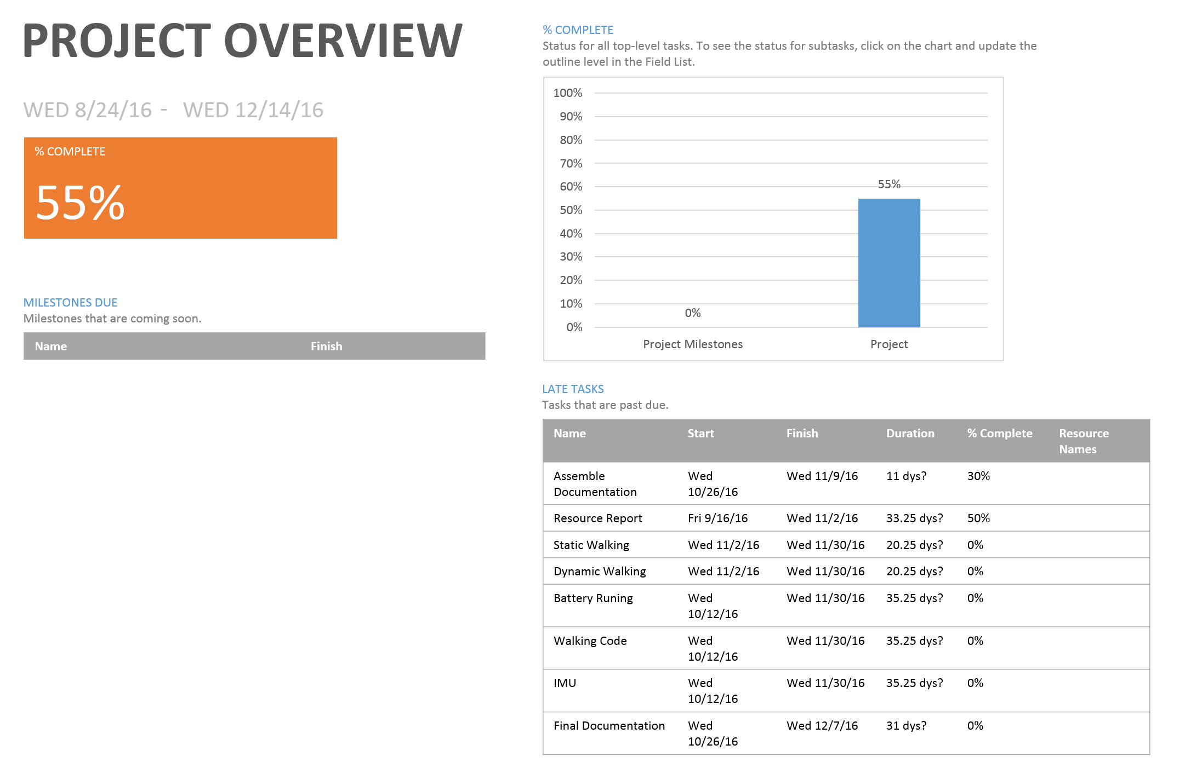
Picture 1: Project Overview

Picture 2: Burndown Structure

Conclusion: The following pictures above shows that the project schedule was not followed. The initial objective on implementing the Theo Jensen biped robot design for the Fall 2016 Velociraptor (W) resulted in 55 percent complete. In addition, due to the setbacks from the complexity of the mechanical design (Feet Design), the control algorithms needed for the Velociraptor were put on hold.

L1-3: Appearance
Requirement: The 3rd Generation Velociraptor (W) should resemble a Velociraptor of the Theropodous Dinosaur Suborder.

Level: System
Type: Should
Method: Inspection
Responsible Division: MFG

Status:

Test Objective: Observe that the Velociraptor (W) resembles a Velociraptor.

Criteria for Success:
- The final build of the velociraptor should resemble a velociraptor

Tools:
- Google image of the Theropodous Dinosaur Suborder
- Velociraptor (W) Robot

Procedure:
- Set up the Fall 2016 Velociraptor (W) for the customer.
- Present the printed Google image of the Velociraptor to the customer.
- Have the customer assess whether the Velociraptor (W) robot resembles the printed image.

Results: The robot undergoes a visual test to see if it resembles a velociraptor and is below the specified length of the columns of the game arena.

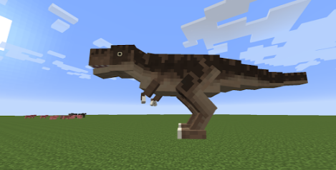
Picture 1: Google Image of Dinosaur
Conclusion: The velociraptor that was built by the Wednesday velociraptor group does resemble an actual velociraptor.

L1-5: 3DoT
Requirement: The 3rd Generation Velociraptor (W) will use a 3DoT board embedded system

Level: Sub - System
Type: Will
Method: Demonstration
Responsible Division: E&C

Status:

Test Objective: Observe that the Velociraptor (W) operates from the control of the 3DoT board and uploaded code.

Criteria for Success:
- The Velociraptor operates from commands that are sent by the Arxterra application to the 3DoT board.

Tools:
- 3DoT board
- Velociraptor
- Arduino IDE
- Micro USB cord
- Velociraptor (W) Robot
- Arxterra Control Panel
- Phone with Arxterra App

Procedure:
- Connect 3DoT board to computer via USB cable
- Open 3DoT firmware code with Arduino IDE
- Upload 3DoT firmware code to the 3DoT board
- Upload the code for the Velociraptor (W) onto the 3DoT board
- Turn on Velociraptor (W) 3DoT board in order to activate Bluetooth communication
- Open Arxterra App on the smartphone
- Open Arxterra App on the computer to initiate controls through community mode if preferred
10. Send commands to the 3DoT board and observe if it is able to receive and implement commands

Results:

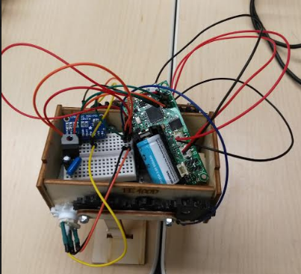
Picture 1: Velociraptor with 3DoT board

Conclusion: The electronics engineer will write control codes that will allow the velociraptor to operate through the 3DoT board commands.

L1-6: DC Motor Torque
Requirement: The DC motor can support the mass of the robot with a 50% margin.

Level: Sub - System
Type: Shall
Method: Test
Responsible Division: E&C

Status: Pass

Test Objective: Test the DC motors to determine if it can support up to 50% of its margin.

Criteria for Success: The DC motors can support a mass no greater than 522 grams.

Procedures:
- Measure the weights that total up to 522g
- Connect the Motor terminals to the 5V power supply
- Attach the weights of the 522g onto the shaft of the motor and observe the movement of the shaft
- Identify the current at which the motor begins to stall

Tools:
- DC Motor GM9
- Weight Scale
- Cup
- String of 24 inches
- Motor Coupler
- 350 grams weight

Results:
Since our robot will weigh about 350 grams, and our gear attached to the shaft is about 1.18 cm, we will test the current draw from the motor at 5 volts. Our requirement states that our motor shall be able to handle the torque at this mass as well as at 50% margin. Our method will be to attach the weight of 522 grams at this radius and measure the current draw. The same method will be used at 525 grams (50% greater mass). We will verify that the current draw will or will not be less than the stall current provided by the datasheet.
3 volts (datasheet) | 6 volts (datasheet) | 5 volts (calculated)
Stall Torque  3.2 kg-cm | Stall Torque  5.5 kg-cm | Stall Torque  4.73 kg-cm

Approximate Mass of Robot | Mass with 50% margin
350 grams | 525 grams

I no load (measured) | I stall (linearized) | I norm (measured) | I margin (measured)
73 mA | 600 mA | 136.8 mA | 166.5 mA

τ stall | τ norm | τ margin
4.73 kg-cm | 0.414 kg-cm | 0.622 kg-cm

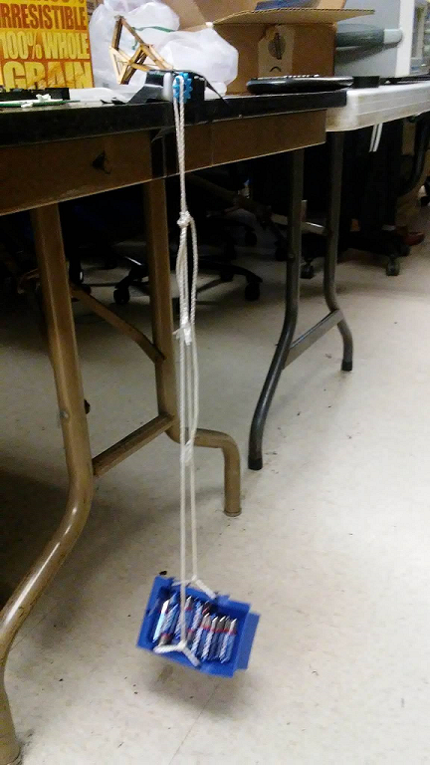
Picture 1: DC Motor torque test

Conclusion: Both the measured current at the regular mass and at the 50% margin are less than the stall current at 5 volts, therefore we can conclude that the motors will be okay to use. The requirement has been met to have a motor that will drive the mass of the robot at 50% margin.

L1-8: Duration
Requirement: The 3rd generation Velociraptor shall operate for a minimum of one hour with an external power resource minimum of 1560 mA-Hours.

Level: System
Type: Shall
Method: Test
Responsible Division: ALL

Status:

Test Objective: Observe that the Velociraptor (W) average current draw is less than what was stated in the power report to be 1560 mA-hours.

Criteria for Success: Measured current draw from Velociraptor is less than Power Resource of 1700 mA-hours.

Tools:
- Velociraptor (W) Robot
- 3DoT Board
- External Battery
- Power Supply
- Arduino IDE
- Micro USB Cord
- Arxterra Control Panel
- Ammeter

Procedure:
- In a series connection, connect the external battery supply to the ammeter
- In a series connection, connect the other end of the ammeter to the Velociraptor
- Make sure that there is proper series connection to the battery supply, ammeter and the robot
- Observe the current reading of the ammeter over 30 seconds to find average current draw during the operation.
- Record ammeter values into a table
- Calculate the average current for the external battery

Results:

Conclusion:

L1-9: Custom PCB
Requirement: The 3rd Generation Velociraptor (W) shall use an external PCB with an I2C interface as the 3DoT board.

Level: System
Type: Shall
Method: Inspection
Responsible Division: ALL

Status:

Test Objective: The velociraptor shall utilize an external PCB which will be able to communicate with the 3DoT board by using the I2C interface

Criteria for Success: The external PCB has a SDA, SCL, VCC and ground connected to the correct pins of the 3DoT boards SDA, SCL, VCC and ground.

Tools:
- External PCB
- Velociraptor (W) Robot
- 3DoT board

Procedure:
- Open the cover of the robot
- Locate external PCB and 3DoT Board
- Observe wire connections are in correct placement for SDA, SCL, VCC, and GND

Results:
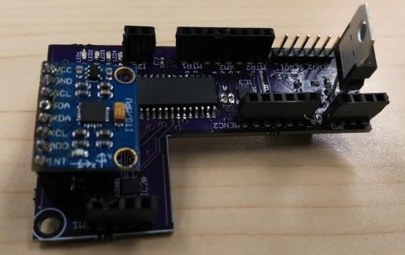
Picture 1: Custom PCB designed by the Velociraptor (W) project

Conclusion:

L1-10: 3DoT Library
Requirement: The velociraptor shall use a 3DoT board library and utilize I2C to communicate with sensors, A/D converter, and GPIO

Level: System
Type: Shall
Method: Inspection
Responsible Division: E&C

Status:

Test Objective: The 3DoT library will be necessary to develop the control codes for implementing the 3DoT board.

Criteria of Success: The 3DoT board will be able to communicate with external sensors and receive data information from sensors

Tools:
- 3DoT Board
- 3DoT Library
- External Sensors

Procedure:
- Download the 3DoT library from the EE400D class website
- Upload the code into the Arduino and test it on the 3DoT board
- Modify code in the 3DoT to customize it to group requirements

Results:
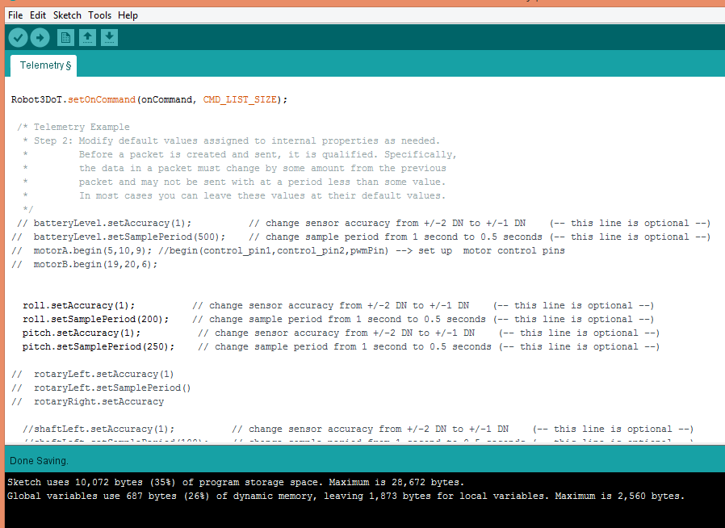
Picture 1: Robot3DoT was the 3DoT library code we had to use in coding the velociraptor

Conclusion: The 3DoT library was modified along with the custom commands and that helped to ensure that the codes that were necessary for the implementation of the 3DoT board worked fine.

L2-1: Mass
Requirement: The 3rd generation Velociraptor shall weight no more than 350 grams

Level: System
Type: Will
Method: Test
Responsible Division: MST

Status: Pass

Test Objective: To calculate the mass of the robot that should be below 350 grams.

Criteria of Success:
- The mass of the Velociraptor (W) robot does not weigh more than 350 grams.

Tools:
- Velociraptor (W) Robot
- Weight Scale

Procedure:
- Grab a weight scale
- Zero the scale before placing the Velociraptor Robot.
- Place the Velociraptor (W) Robot on the scale
- Read the displayed value from the scale
- Record the value of the velociraptor

Results:
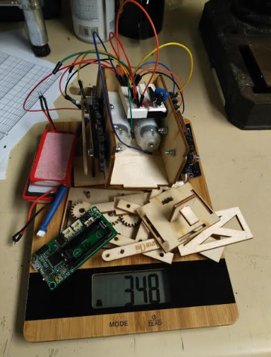
Picture 1: Measured Mass of 348 grams for the Velociraptor (W) Robot

Conclusion: The overall weight of the Velociraptor is 348 grams which is less than the expected amount of 350 grams. In conclusion the Velociraptor successfully met the mass requirement.

L2-2: Turn
Requirement: The 3rd Generation Velociraptor (W) shall turn 0-360 degrees on one leg under one minute.

Level: System
Type: Shall
Method: Test
Responsible Division: E&C

Status:

Test Objective: Apply extra mass to the robot to be equivalent to 522 grams

Criteria for Success: The motors of the robot do not stall when receiving a forward command while driving the 50% margin of mass

Tools:
- Velociraptor
- Arxterra App
- Masses equivalent to 168.5 grams
- Tape

Procedure:
- Separate mass into equivalent halves of 261 grams
- Attached the mass onto the head and tail of the velociraptor
- Connect Arxterra phone to 3DoT Board
- Connect to the velociraptor either through the community mode or remote control
- Turn on velociraptor 3DoT board in order to activate Bluetooth communication
- Open Arxterra App on the smartphone
- Open Arxterra App on the computer to also initiate controls through community mode
- If commands are to be initiated through the phone, select remote control mode
- If commands are to be initiated through the control panel on the computer, make sure activate
- Press forward button and observe movement of the velociraptor

Results:

Conclusion:

L2-3: Custom Commands
Requirement: The 3rd generation Velociraptor (W) shall create custom commands to be used with the Arxterra Control Panel.

Level: System
Type: Shall
Method: Test
Responsible Division: MST

Status:

Test Objective: The 3DoT board library has been updated with custom command codes that are specific to the velociraptor and it is able to receive controls through those commands.

Criteria for Success: The velociraptor is designed with additional custom commands included in the 3DoT library and is able to receive specialized commands through the custom commands.

Tools:
- 3DoT board
- 3DoT library
- Arxterra Control Panel
- Arduino IDE
- Micro USB Cable
- Velociraptor

Procedure:
- Have robot start in standing position at determined spot in game
- Connect to the velociraptor either through the community mode on the computer or through the remote control mode
- Turn on velociraptor 3DoT board in order to activate Bluetooth communication
- Open Arxterra App on the smartphone
- Open Arxterra App on the computer to also initiate controls through community mode if preferred
- Log into Arxterra account to activate custom commands
- If commands are to be initiated through the phone, select remote control mode and control velociraptor as desired
- If commands are to be initiated through the control panel on the computer, make sure activate community mode
- Use controls on Arxterra Control Panel to move the robot and participate in game

Results: A custom command of static walk has been updated into the 3DoT library and the velociraptor is able to statically walk based on the controls of that command function.

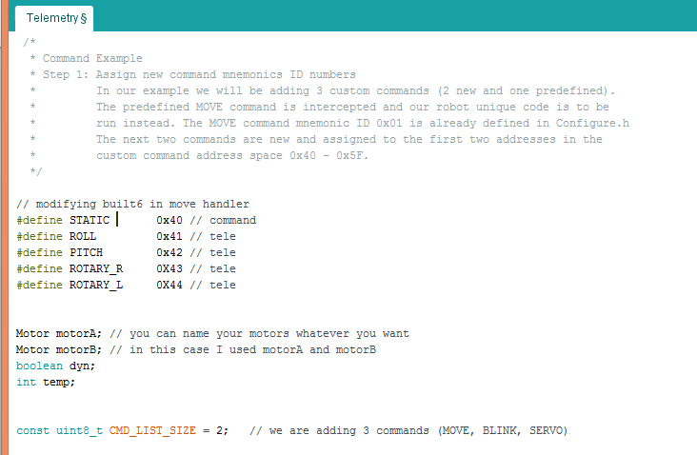
Picture 1: Custom Commands Created in Arduino

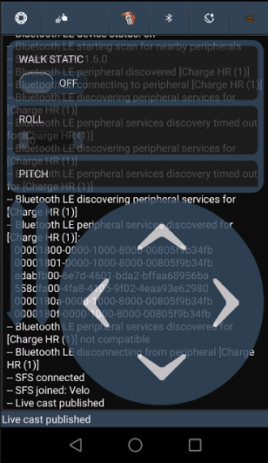
Picture 2: Remote Control Interface of Control Panel

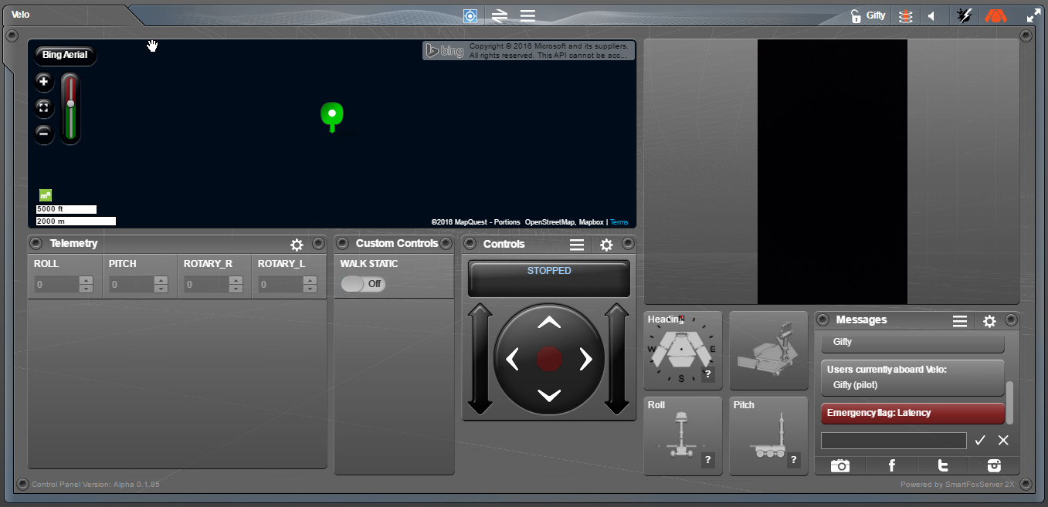
Picture 3: Control Panel Interface

Conclusion: The velociraptor group created one custom command in the 3DoT library. The custom command created was to initiate static walking of the velociraptor.

L2-4: IMU Sensor
Requirement: The velociraptor shall use the IMU MPU6050 that tracks acceleration and gyration that can provide X and Y angles to +/- 6.5 degree precision.

Level: Sub-System
Type: Shall
Method: Test
Responsible Division: MST/E&C

Status:

Test Objective: The Arduino code is able to help have the IMU sensor output values onto the serial monitor and provide a range of angles at which it is operating.

Criteria of Success: The Arduino program will serial write outputs of IMU data.

Tools:
- IMU MPU6050
- Computer
- Arduino
- Arduino Cable for connection
- Wires
- Protractor
- Breadboard

Procedure:
- For the IMU MPU6050 sensor, identify the different outputs that are on the sensor that are needed for the testing of the sensor: SCL, SDA, VCC, INT and GND
- Connect the IMU MPU6050 sensor onto the external breadboard and have wires to be able to pick up the outputs identified above
- Connect the VCC wire from the IMU sensor to the 5V on the Arduino (Duemilanove)
- Connect the INT pin from the IMU sensor to digital pin 2 on the Arduino (Duemilanove)
- Below this procedure section, find the code for the IMU testing that measures gyration, acceleration and temperature and displays it on the screen
- Upload the code from the Arduino

Results:
X angle with protractor | X value displayed by computer | Y angle with protractor | Y value displayed by computer
0 | -1192 | 0 | -134
6.5 | -2529 | 6.5 | -1180
13 | -4205 | 13 | -2516
30 | -5943 | 30 | -8191
45 | -11028 | 45 | -10928
60 | -14151 | 60 | -13592
90 | -16130 | 90 | -16153

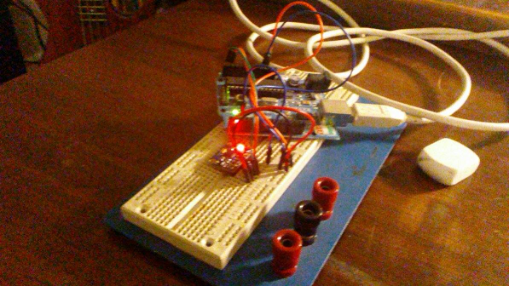
Picture 1: This figure shows the IMU at 0 degrees

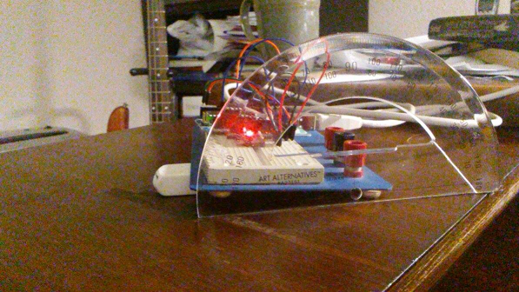
Picture 2: This figure shows the IMU at 6.5 degrees

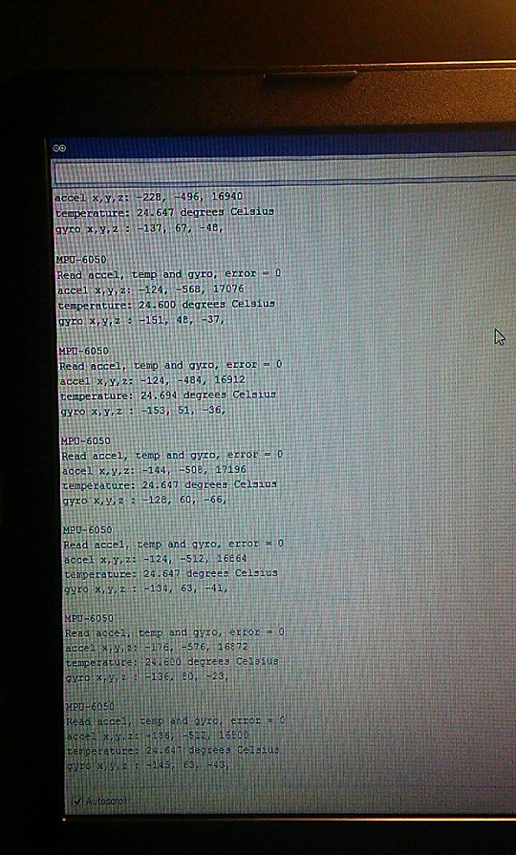
Picture 3: Reading from 6.5 degrees in the x direction

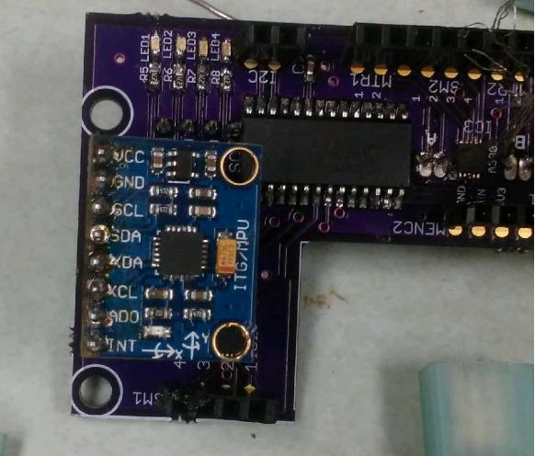

Picture 4: IMU sensor

Conclusion: From the results of the table, we can see the different acceleration values from different angles of the IMU. There is a significant difference between 0 degrees and 6.5 degrees. This means that this IMU meets our requirement that it should have a tolerance of at least +/- 6.5 degrees.

L2-5: Rotary Sensor

Requirement: The velociraptor shall use a rotary sensor that tracks at 90 degrees’ precision to determine the position of leg. The leg position controls the head and tail location.

Level: Sub-System
Type: Shall
Method: Test
Responsible Division: ALL

Status:

Test Objective: The rotary sensor will be able to detect the leg position of the velociraptor while walking

Criteria of Success: The Arduino program will serial write outputs of potentiometer sensors data at predetermined angles.

Tools:
- Rotary Encoder
- Adafruit 1015 A/D converter
- Arduino
- Breadboard
- Alligator Wires
- Male connectors
- Computer
- Test code to read A/D converter
- Protractor
- Screwdriver

Procedure:
- Connect VCC and ground of the rotary encoder to VCC and GND of the Arduino.
- Using a breadboard, connect VCC, ground, serial clock, and serial data of the A/D to the VCC, ground, serial ground, and serial data of the Arduino. Connect the address pin to ground.
- Using alligator clips and male pin headers, connect the signal from the rotary encoder to A0 of the A/D converter.
- Plug the Arduino into the computer.
- Upload the test code and open the serial monitor under tools in Arduino IDE.
- Using the screwdriver and protractor, move the shaft of the encoder and record data from the A/D converter.

Results:
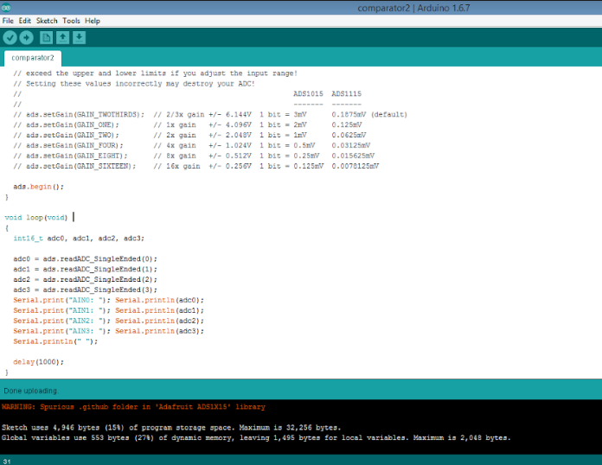
Picture 1: Arduino code for the rotary sensor implementation

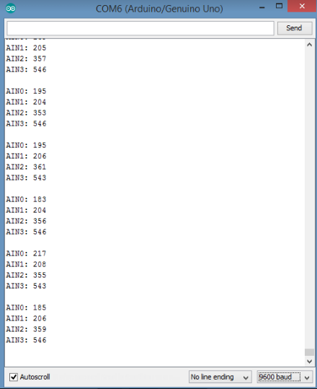
Picture 2 : Serial monitor output of encoder values

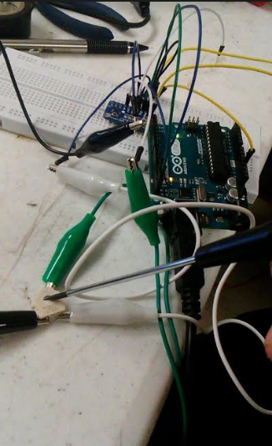
Picture 3: Connection between rotary encoder and Arduino

Conclusion: By using the A/D converter the ADS1015 converts an analog voltage that spans from 0-3.3V to bit values from 0-1100.

L2-7a: Structural Test – 1st Point
Requirement: The velociraptor shall support the mass of the robot with a 50% margin, 522g in a 0 degree position (Footstep is down on the ground).

Level: System
Type: Shall
Method: Test
Responsible Division: ALL

Test Objective: To verify the leg mechanism can stand at a 0 degree position when the footstep is down on the ground

Criteria of Success: The robot is placed upside down and has mass of 522g placed on the feet at 0 degrees

Tools:
- Velociraptor
- Weights (522g)
- Box for the weights

Procedure:
- Put robot upside down as to where it’s back is parallel to the ground
- Place the 522g into a box
- Weigh the mass to ensure that it equals the weight of 522g
- Place the mass on the velociraptor while it is standing at a 0 degree position

Results:
Picture 1 : The velociraptor supporting mass while placed at 0 degree angle

Conclusion: The velociraptor leg designed was able to support the weight of 522g which is up to 50% margin of its total weight while placed at a 0 degree angle. This test was successful and the legs of the velociraptor did not get damaged in the process.

L2-7b: Structural Test- 2nd Point
Requirement: The velociraptor shall support the mass of the robot with a 50% margin, 522g in a 90 degree position (Center of foot path on ground).

Level: System
Type: Shall
Method: Test
Responsible Division: ALL

Test Objective: To verify the leg mechanism can stand at 90 a degree position when the footstep is down on the ground

Criteria of Success: The robot is placed upside down and has mass of 522g placed on the feet at 90 degrees

Tools:
- Velociraptor
- Weights (522g)
- Box for the weights

Procedure:
- Put robot upside down as to where its back is parallel to the ground
- Place the 522g into a box
- Weigh the mass to ensure that it equals the weight of 522g
- Place the mass on robot while standing at a 90 degree position (footstep is down on the ground )

Results:
Picture 1: The velociraptor supporting mass while placed at 90 degree angle

Conclusion: The velociraptor leg designed was able to support the weight of 522g which is up to 50% margin of its total weight while placed at a 90 degree angle. This test was successful and the legs of the velociraptor did not get damaged in the process.

L2-7c: Structural Test- 3rd Point

Requirement: The velociraptor shall support the mass of the robot with a 50% margin, 522g in a 180 degree position (Time before foot goes to ground).

Level: System
Type: Shall
Method: Test
Responsible Division: ALL

Status:

Test Objective: To verify the leg mechanism can stand at a 180 degree position when the footstep is down on the ground

Criteria of Success: The robot is placed upside down and has mass of 522g placed on the feet at 180 degrees

Tools:
- Velociraptor
- Weights (522g)
- Box for the weights

Procedure:
- Put robot upside down as to where it’s back is parallel to the ground
- Place the 522g into a box
- Weigh the mass to ensure that it equals the weight of 522g
- Have the mass on robot while standing at 180 degree position (Time before foot goes to ground )

Results:
Picture 1: The velociraptor supporting mass while placed at 180 degree angle

Conclusion: The velociraptor leg designed was able to support the weight of 522g which is up to 50% margin of its total weight while standing in a 180 degree angle. This test was successful and the legs of the velociraptor did not get damaged in the process.

L2-8: Single Servo Control – Head and Tail
Requirement: The velociraptor shall control the head and tail movement with a single servo using gear trains

Level: Sub-System
Type: Shall
Method: Test
Responsible Division: MFG

Status: Success

Test Objective: The velociraptor uses a single servo to control the head and tail movement through a gear train

Criteria of Success: A single servo is able to control the head and tail movements through a gear train

Tools:
- Tower Pro Micro Servo SG90
- Top layer of velociraptor
- Head and Tail of Velociraptor

Procedure:
- Assemble gear train for the head and tail servo
- Attach battery packs on the slot on top of the head and tail platform
- Connect the servo on the bottom of the head and tail platform
- Move the head and tail of the velociraptor manually to see if the gear train works properly

Results:

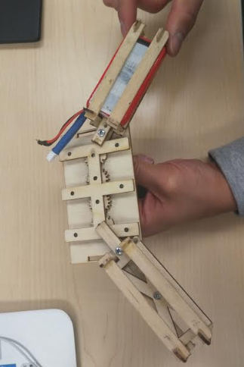
Picture 1: Single Servo Control for the Head and Tail (Positon A)

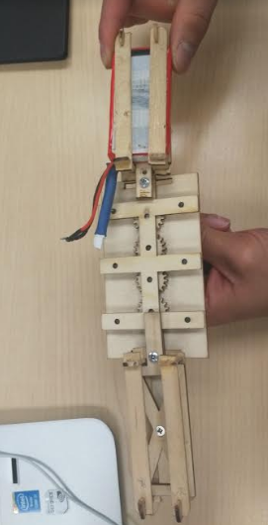
Picture 2 : Single Servo Control for the Head and Tail (Position B)

Conclusion: The single servo for the head and tail is able to control the movements using the gear train control mechanisms.

L2-9: Torque- Head and Tail

Method: Test

Type: Shall

Requirement: The head and tail shall use one servo that operates at an optimal torque of 18-45mN-m to maintain center of gravity

Tools:
- Ammeter
- Head and Tail
- Data Sheet on Torque characteristics

Procedure:
- The head and tail servo analysis was done using a method of current measurements
- Evaluate the data sheet torque characteristics
- Linearize torque parameters to determine the actual torque by the head and tail

Test Objective: The center of gravity is maintained and the servo does not stall during operation

Criteria: The head and tail shall operate within the specified range in order to main proper center of gravity

Results:

4.8 V Torque | 6.6 V Torque | 6.6 V Linear | 6.6 V Exponential
1.8 kg-cm | 2.2 kg-cm | 2.48 kg-cm | 2.37 kg-cm

The specification torque for the various voltages tested was found to be at an operating rate of 3.7V. Analyzation of the linear fit between the two voltages listed in the data sheet was also linear and then an exponential fit of the data sheet values were performed in order to get a better approximation. Base off the testing results, the fit between the spec sheet voltage level and the actual voltage level will be used because a better approximation of the actual value was calculated.

Stall current was measured and recorded as well as current at 50% margin and 50% margin with a 6.5 degree incline.
Mass | With Margin
72 g | 108 g

Current_{NO LOAD} | Current_{FullLoad} | Current_{Norm} | Current_{Margin} | Current_{Margin,Inline}
3.2 mA | 365.6 mA | 43.5 mA | 113 mA | 185 mA

T_{NoLoad} | T_{FullLoad} | T_{Norm} | T_{Margin} | T_{Margin,Inline}
1.14 mN-m | 130.57 mN-m | 15.54 mN-m | 40.36 mN-m | 66.07 mN-m

Conclusion: The torque generated with 50% margin is less than the limits of the servo and very close to the predicted torque values listed in an earlier blog post. This successfully fulfills the head and tail servo requirements.

L2-10

Requirement Title: Center of Gravity - Head and Tail

Method: Test

Type: Shall

Requirement: The CoG on the axis of the H/T shall be controlled by one servo while being placed over the foot.

Tools:
- Servo
- Velociraptor
- Head and Tail of Velociraptor
- Arxterra Control Panel

Procedure:
- Open SolidWorks assembly
- Assign each component’s material to specified density
- Click on the View tab, then click on Center of mass.
- Shift head to degree ranges of choice
- Click on the Evaluate tab, then click Measure
- Click on edge of Head then edge of front body
- Degree will be given as Angle in table
- Observe the Center of Mass over the foot of the robot from a top view
- Record data on table

Criteria: The head and tail servo will be able to shift its CoG over the foot of the velociraptor

Test Objective: To be able to determine how far we can shift the CoG can be moved over the foot to avoid tipping over.

Results:
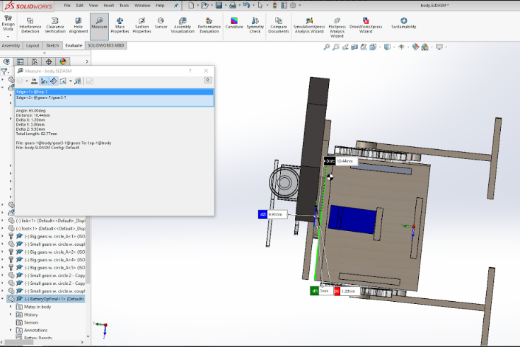
Picture 1: Side view of servo shifted to be placed over the foot

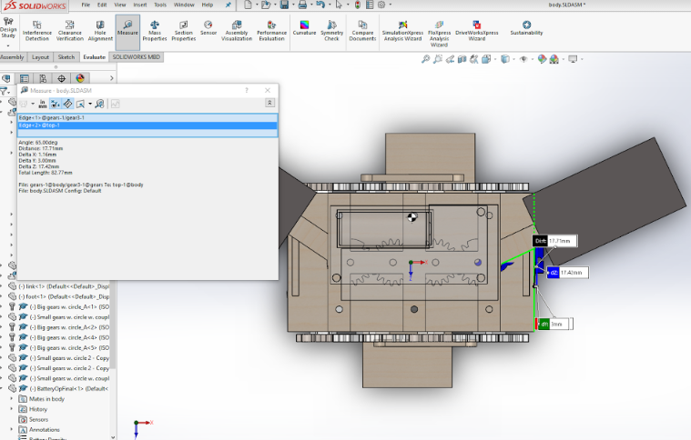
Picture 2: A top view of the servo shifted and being placed over the foot

Conclusion: Observing from SolidWorks, the degree that the velociraptor can rotate the head and tail to a maximum of 35 degrees. This assumes that if the head and tail were straight, then the head would be 90 degrees from the body. Turning 35 degrees would shift the center of mass over the foot.

L2-16

Requirement Title: Power to External

Method: Test

Type: Will

Requirement: The velociraptor will not exceed a rating of 1A with the use of the LDO with the external PCB

Tools:
- Arxterra App
- Arxterra Control Panel
- Velociraptor
- Ammeter

Procedure:
- Open Arduino IDE
- Upload code to 3DoT board
- Open Arxterra Phone App
- Connect phone to 3DoT
- Turn on community mode
- On Computer, go to Arxterra Control Panel
- Connect the ammeter in between the 3DoT board, VCC and PCB external 3.3V
- Observe the results of the ammeter

Test Objective: To be verify that the LDO will be protected from overheating

Criteria: During operation, the current will be measured between the 3DoT board VCC and PCB external 3.3V

Results:

Conclusion:

L2-17

Requirement Title: Custom Telemetry

Method: Test

Type: Should

Requirement: The velociraptor shall utilize custom telemetry commands that will be displayed on the Arxterra Control Panel.

Tools:
- 3DoT board
- 3DoT library
- Arxterra Control Panel
- Android/Iphone
- Computer

Procedure:
- Turn on velociraptor 3DoT board in order to activate Bluetooth communication
- Open Arxterra App on the smartphone
- Open Arxterra App on the computer to also initiate controls through community mode if preferred
- Log into Arxterra account to observe changes in telemetry values

Test Objective: The 3DoT board library will be updated with telemetry custom command codes that are specific to the velociraptor and it is able to send output data to the control panel.

Criteria: The velociraptor is designed with additional custom telemetry commands included in the 3DoT library and is able to receive telemetry data that is commands through the custom commands.

Results: A custom telemetry command code was created and modify 3DoT library and the velociraptor is able to statically walk based on the controls of that command function.

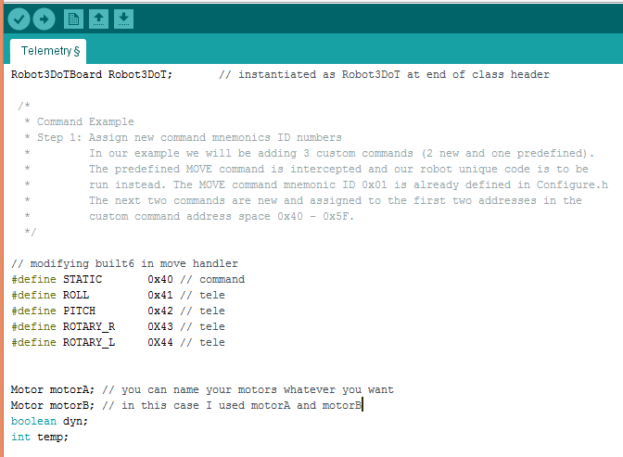
Picture 1: Defining the telemetry custom commands

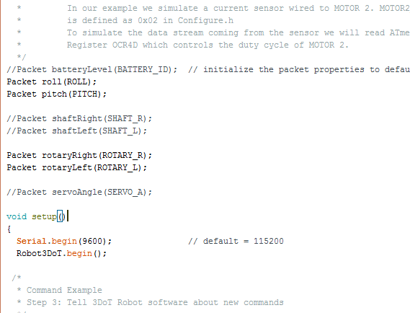
Picture 2: Defining packet ID’s for telemetry commands

Conclusion: A telemetry custom command will be programmed by the systems engineer and will be able to display code received from the velociraptor onto the Arxterra control panel.

L1-S1

Requirement Title: Static Walk – Flat Surface

Method: Test

Type: Shall

Requirement: The 3 rd generation velociraptor shall walk on a flat surface

Tools:
- A computer with Arxterra Control Panel
- Computer with Arduino IDE software
- USB to micro-USB cable
- 3DoT firmware code
- Velociraptor Robot
- Flat surface

Procedure:
- Open 3DoT firmware code with Arduino IDE
- Upload 3DoT firmware code to the 3DoT board on Velociraptor
- Turn on phone and turn on Bluetooth
- Open Arxterra App on the smartphone
- Connect phone to Arxterra Control Panel on computer through community mode
- Connect Bluetooth Module on 3DoT board to phone
- Turn off dynamic walking mode and initiate static walking
- Send move commands to robot and observe walking for 45 seconds
- Observe if the velociraptor is able to demonstrate static walking on an flat surface

Test Objective: The velociraptor will be able to demonstrate static walking on a flat surface after it receives a move command from the Arxterra application

Criteria: The velociraptor performs static walking on a flat surface

Results:

Conclusion:

L1-S2

Requirement Title: Static Walk – Surface Texture

Method: Test

Type: Shall

Requirement: The 3 rd generation velociraptor shall walk on a surface texture

Tools:
- A computer with Arxterra Control Panel
- Computer with Arduino IDE software
- USB to micro-USB cable
- 3DoT firmware code
- Velociraptor Robot
- Surface Texture

Procedure:
- Open 3DoT firmware code with Arduino IDE
- Upload 3DoT firmware code to the 3DoT board on Velociraptor
- Turn on phone and turn on Bluetooth
- Open Arxterra App on the smartphone
- Connect phone to Arxterra Control Panel on computer through community mode
- Connect Bluetooth Module on 3DoT board to phone
- Turn off dynamic walking mode and initiate static walking
- Send move commands to robot and observe walking for 45 seconds
- Observe if the velociraptor is able to demonstrate static walking on a surface texture

Test Objective: The velociraptor will be able to demonstrate static walking on a surface texture after it receives the commands to walk

Criteria: The velociraptor performs static walking on a surface texture

Results:
Conclusion:

L1-S3

Requirement Title: Static Walk – Incline/Decline

Method: Test

Type: Shall

Requirement: The 3 rd generation velociraptor shall walk on an incline and decline surface

Tools:
- A computer with Arxterra Control Panel
- Computer with Arduino IDE software
- USB to micro-USB cable
- 3DoT firmware code
- Velociraptor Robot
- Incline Surface

Procedure:
- Open 3DoT firmware code with Arduino IDE
- Upload 3DoT firmware code to the 3DoT board on Velociraptor
- Turn on phone and turn on Bluetooth
- Open Arxterra App on the smartphone
- Connect phone to Arxterra Control Panel on computer through community mode
- Connect Bluetooth Module on 3DoT board to phone
- Turn off dynamic walking mode and initiate static walking
- Send move commands to robot and observe walking for 30 seconds
- Observe if the velociraptor is able to demonstrate static walking on an incline and decline

Test Objective: The velociraptor will be able to demonstrate static walking on an incline and decline

Criteria: The velociraptor performs static walking on an incline and decline

Results:

Conclusion:

L1-S4

Requirement Title: Static Walk – Step

Method: Test

Type: Shall

Tools:
- A computer with Arxterra Control Panel
- Computer with Arduino IDE software
- USB to micro-USB cable
- 3DoT firmware code
- Velociraptor Robot
- Step Surface

Procedure:
- Open 3DoT firmware code with Arduino IDE
- Upload 3DoT firmware code to the 3DoT board on Velociraptor
- Turn on phone and turn on Bluetooth
- Open Arxterra App on the smartphone
- Connect phone to Arxterra Control Panel on computer through community mode
- Connect Bluetooth Module on 3DoT board to phone
- Turn off dynamic walking mode and intiate static walking
- Send move commands to robot and observe walking for 45 seconds
- Observe if the velociraptor is able to demonstrate static walking on a step

Test Objective: The velociraptor will be able to demonstrate static walking on a step

Criteria: The velociraptor performs static walking on a step

Results:
Conclusion:

L1-D1

Requirement Title: Dynamic Walk – Flat Surface

Method: Test

Type: Should

Requirement: The 3 rd generation velociraptor should perform dynamic walking while on a flat surface

Tools:
- Velociraptor
- Arxterra Control Panel
- 3DoT board
- External PCB
- Android/Iphone
- Arduino IDE software
- USB to micro-USB cable
- 3DoT firmware code
- Cardboard (Step)

Procedure:
- Open 3DoT firmware code with Arduino IDE
- Upload 3DoT firmware code to the 3DoT board on Velociraptor
- Turn on phone and turn on Bluetooth
- Open Arxterra App on the smartphone
- Connect phone to Arxterra Control Panel on computer through community mode
- Connect Bluetooth Module on 3DoT board to phone
- Turn off dynamic walking mode
- Send move commands to robot and observe walking on a flat surface

Test Objective: The velociraptor is able to perform dynamic walking on a flat surface

Criteria: The velociraptor is able to demonstrate dynamic walking on a flat surface

Results: The velociraptor’s current design does not allow it to perform dynamic walking

Conclusion: The velociraptor is not able to shift its center of mass from one leg to the other and can therefore not perform dynamic walking on a flat surface.

L1-D2

Requirement Title: Dynamic Walk – Surface Texture

Method: Test

Type: Shall

Requirement: The 3 rd generation velociraptor should perform dynamic walking while on a surface texture.

Tools:
- Velociraptor
- Arxterra Control Panel
- 3DoT board
- External PCB
- Android/Iphone
- Arduino IDE software
- USB to micro-USB cable
- 3DoT firmware code
- Cardboard (Step)

Procedure:
- Open 3DoT firmware code with Arduino IDE
- Upload 3DoT firmware code to the 3DoT board on Velociraptor
- Turn on phone and turn on Bluetooth
- Open Arxterra App on the smartphone
- Connect phone to Arxterra Control Panel on computer through community mode
- Connect Bluetooth Module on 3DoT board to phone
- Turn off dynamic walking mode
- Send move commands to robot and observe walking on a surface texture

Test Objective: The velociraptor is able to demonstrate dynamic walking on a surface texture

Criteria: The velociraptor is able to perform dynamic walking while placed on a surface texture

Results: The velociraptor’s current design does not allow it to perform dynamic walking on a surface texture

Conclusion: The velociraptor is not able to shift its center of mass from one leg to the other and can therefore not perform dynamic walking on a surface texture.

L1-D3

Requirement Title: Dynamic Walk – Incline/Decline

Method: Test

Type: Shall

Requirement: The 3 rd generation velociraptor should perform dynamic walking while on an incline and decline.

Tools:
- Velociraptor
- Arxterra Control Panel
- 3DoT board
- External PCB
- Android/Iphone
- Arduino IDE software
- USB to micro-USB cable
- 3DoT firmware code
- Cardboard (Step)

Procedure:
- Open 3DoT firmware code with Arduino IDE
- Upload 3DoT firmware code to the 3DoT board on Velociraptor
- Turn on phone and turn on Bluetooth
- Open Arxterra App on the smartphone
- Connect phone to Arxterra Control Panel on computer through community mode
- Connect Bluetooth Module on 3DoT board to phone
- Turn off dynamic walking mode
- Send move commands to robot and observe walking for up incline and decline

Test Objective: The velociraptor is able to demonstrate dynamic walking on an incline and decline

Criteria: The velociraptor is able to perform dynamic walking while placed on an incline or decline

Results: The velociraptor’s current design does not allow it to perform dynamic walking while on an incline or decline

Conclusion: The velociraptor is not able to shift its center of mass from one leg to the other and can therefore not perform dynamic walking on an incline or decline.

L1-D4

Requirement Title: Dynamic Walk – Step

Method: Test

Type: Should

Requirement: The 3rd generation velociraptor should perform dynamic walking while on a step

Tools:
- Velociraptor
- Arxterra Control Panel
- 3DoT board
- External PCB
- Android/Iphone
- Arduino IDE software
- USB to micro-USB cable
- 3DoT firmware code
- Cardboard (Step)

Procedure:
- Open 3DoT firmware code with Arduino IDE
- Upload 3DoT firmware code to the 3DoT board on Velociraptor
- Turn on phone and turn on Bluetooth
- Open Arxterra App on the smartphone
- Connect phone to Arxterra Control Panel on computer through community mode
- Connect Bluetooth Module on 3DoT board to phone
- Turn off dynamic walking mode
- Send move commands to robot and observe dynamic walking on the step

Test Objective: The velociraptor is able to demonstrate dynamic walking on a step surface

Criteria: The velociraptor is able to perform dynamic walking while placed on step surface

Results: The velociraptor’s current design does not allow it to perform dynamic walking

Conclusion: The velociraptor is not able to shift its center of mass from one leg to the other and can therefore not perform dynamic walking on a step.

